SUMMER TRAINING/INTERNSHIP

PROJECT REPORT

(Term June-July 2025)

**PlayCam: Real-Time Cricket Shot Classification using Pose Keypoints and LSTM**

**Submitted by**

**Dev Krishna(12321681)**

**Ashutosh Kumar Sonu(12321584)**

**Course Code PETV79**

**Under the Guidance of**

**Mr. Mahipal Singh Papola**

**School of Computer Science and Engineering**



**Lovely Professional University, Punjab**

BONAFIDE CERTIFICATE

Certified that this project report **“PlayCam: Real-Time Cricket Shot Classification using Pose Keypoints and LSTM”** is the Bonafide work of **DEV KRISHNA and ASHUTOSH KUMAR SONU** who carried out the project work under my supervision.

**SIGNATURE**  
<<Name of the Supervisor>>

**DEV KRISHNA**

**ASHUTOSH KUMAR SONU**

**SIGNATURE**

<<Signature of the Head of the Department>>  
SIGNATURE  
<<Name>>  
**HEAD OF THE DEPARTMENT**

<<Signature of the Supervisor>>

**ACKNOWLEDGEMENT**

I (Dev Krishna) express my sincere gratitude to my mentor Mr. Mahipal Singh Papola for providing guidance and continuous encouragement throughout this project and also to my friend Mr. Ashutosh Kumar Sonu. This project would not have been possible without their support and hard work.

Table of Contents

**1. Introduction  
2. Objectives  
3. Technologies Used  
4. Proposed System  
5. Implementation Details  
6. Previous Approaches and Shift in Plan  
7. Final Results  
8. Conclusion  
9. Future Scope**

**Introduction**

This project is named **PlayCam**. It is developed to detect and classify **cricket shots** using a normal webcam. It uses **MediaPipe**, a tool that can track body movements like hands, face, and pose, and a machine learning model called **LSTM** (Long Short-Term Memory) to understand what shot the player is playing.

The idea came after seeing **VR games** and **motion sensor cricket games**, which are fun but expensive. Not everyone can buy VR sets or sensor devices. So I thought ***why not use a simple webcam*?** Almost every laptop has one, and it costs nothing extra. This project is made to prove that **even a normal webcam can be used to play VR level games** or test performance using just body movement.

The system captures the short video (around 1 second with 30 frames), and predicts the type of cricket shot. The four shots used in this project currently are:

* **Cover Drive**
* **Pull Shot**
* **Straight Drive**
* **Sweep Shot**

In the future, this can be connected to a real cricket game where the webcam will read your body movement and trigger the right shot although things are in progress but due to input delay in the game it is taking some more time.

**Objectives**

The main goal of this project is to create something useful and fun using just a webcam. We see many cricket games that work with VR or sensors, but they are expensive. So I wanted to build a system that works with only a normal camera, no extra cost, no special setup.

The idea is simple: use the webcam to look at the body movements, understand what cricket shot is being played, and then classify it correctly. Here's what I planned to achieve in this project:

* To detect human body movement using MediaPipe, which gives us points of the face, hands, and pose by extracting 1662 points.
* To collect these points for every frame, and build a set of 30 frames which represent the full movement of a shot.
* To train a model using LSTM, which can learn movements over time and predict the shot type.
* To focus on four shots only: Cover Drive, Pull Shot, Straight Drive, and Sweep Shot.
* To test the system with real-time camera input and check how fast and accurate it works.
* And finally, to prepare the system in a way that in future, it can be connected with a cricket game, so players can play using their **body**, not just with VR, Keyboard or Joystick.

**Technologies Used**

To build this project, I used some python libraries. Each libraries had its own role like detecting pose, handling the webcam, training the model, etc.

Below is a list of technologies I used and what I used them for:

| Tool / Library | What I used it for |
| --- | --- |
| Python | Main language to write the full project |
| OpenCV | To open the webcam, show camera window, and capture frames |
| MediaPipe | To detect body pose, hands, and face points(Holistic) |
| NumPy | For handling arrays, keypoints, and sequences |
| TensorFlow + Keras | To build and train the LSTM model |
| Scikit-learn | To split data and one-hot encode the labels |
| Pyttsx3 | To add text-to-speech so the system can speak(Game Implemented Version) |
| Keyboard | To detect ‘S’(Current Hotkey) or hotkey press for triggering shot capture |

Each of these tools helped make the system smart, fast, and real-time ready.

**Proposed System**

The workflow of this project is like:

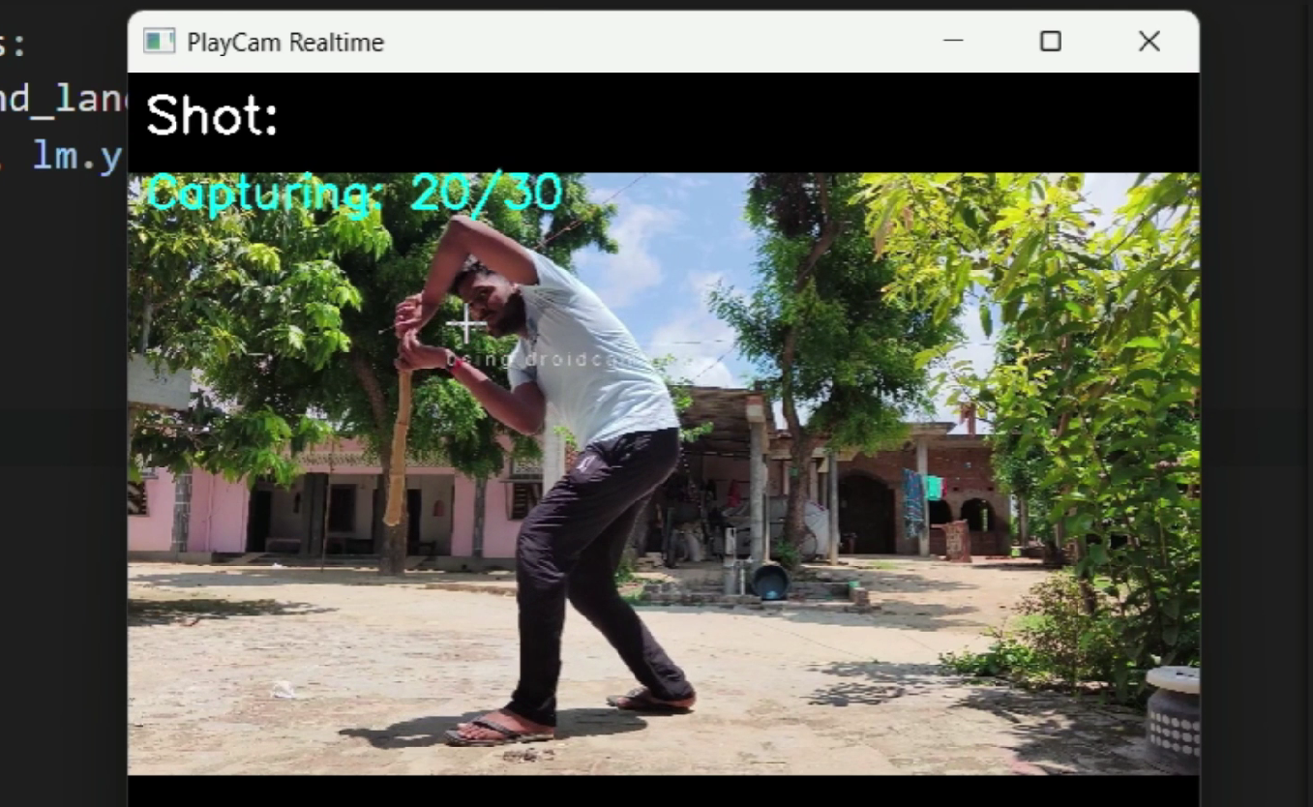

1. Input Video (webcam or mp4 dataset)  
2. Extract Keypoints using MediaPipe Holistic  
3. Form Sequences of 30 frames = 1 sample of shape (30, 1662)  
4. Train LSTM model on the sequences  
5. Predict Shot in Real-Time using webcam

**Webcam → MediaPipe → 30 Frames → LSTM Model → Predicted Shot → Display / Trigger**  
6. (In Progress) Simulate keypress or controller input based on predicted shot

**Implementation Details**

To make this project work smoothly, I divided the whole process into four main parts:

**a) Dataset Preparation**

* I recorded 4 videos, one for each cricket shot: **Cover, Pull, Straight, Sweep** (Took only 4 shots in the start of building the model)
* Each video was around **20–25 seconds** long, where the shot was played again and again (clips of same type shot played are compiled in one).
* The videos were saved inside folders named after each shot.

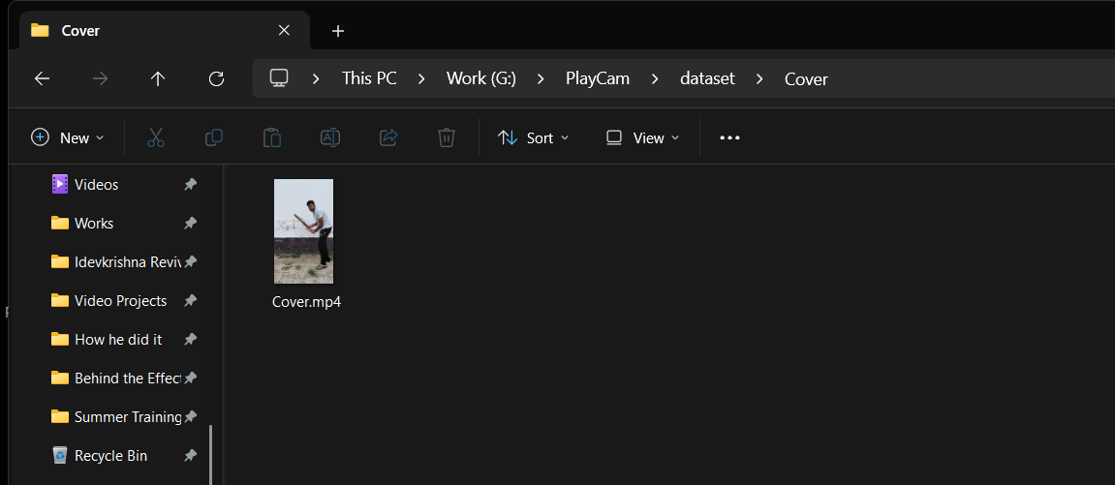  
File Structure is like (dataset → {Shot_name} → {Shot-name}.mp4)

**b) Keypoint Landmarks Extraction using MediaPipe**

* For each video, I extracted **pose, hand, and face keypoints** from every frame using **MediaPipe Holistic**.
* One frame gives **1662 values**:
  + Pose: 33 points × 4 (x, y, z, visibility) = 132
  + Face: 468 points × 3 = 1404
  + Left hand: 21 × 3 = 63
  + Right hand: 21 × 3 = 63
* These keypoints were stored as .npy files (NumPy arrays) in MP_Data Folder.
* I also made **overlapping sequences**: every 5 frames, a new 30-frame sequence is created to increase training data as only single video of around 25 sec used for training a particular shot.

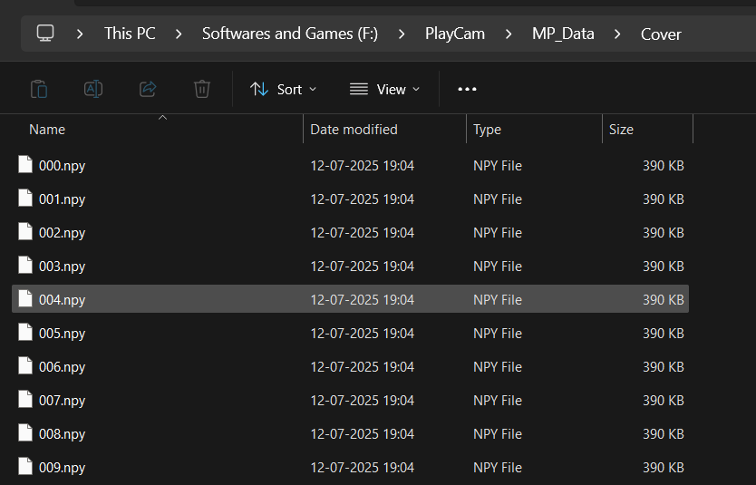

**c) Model Training using LSTM**

* I used a deep learning model with **2 LSTM layers**, followed by **Dense** and **Dropout**.
* Input to model: (30, 1662) shape (30 frames × 1662 keypoints)
* Output: 4 classes (one for each shot)

**Model structure:**

**LSTM(128) → LSTM(64) → Dense(64, relu) → Dropout(0.3) → Dense(4, softmax)**

* The model was trained for **30 epochs** using **categorical crossentropy** and **Adam optimizer**.
* Validation accuracy achieved: **98.18%**

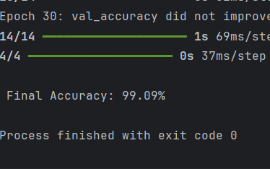

**d) Real-Time Prediction**

* The final model was used in a webcam application.
* When user presses 'S'(Current Hotkey) or desired hotkey, the system:
  + Shows “Get Ready” message
  + Collects 30 frames of keypoints
  + Predicts the shot
  + Displays it live on screen using OpenCV
  + Only accepts predictions with **80%+ confidence**

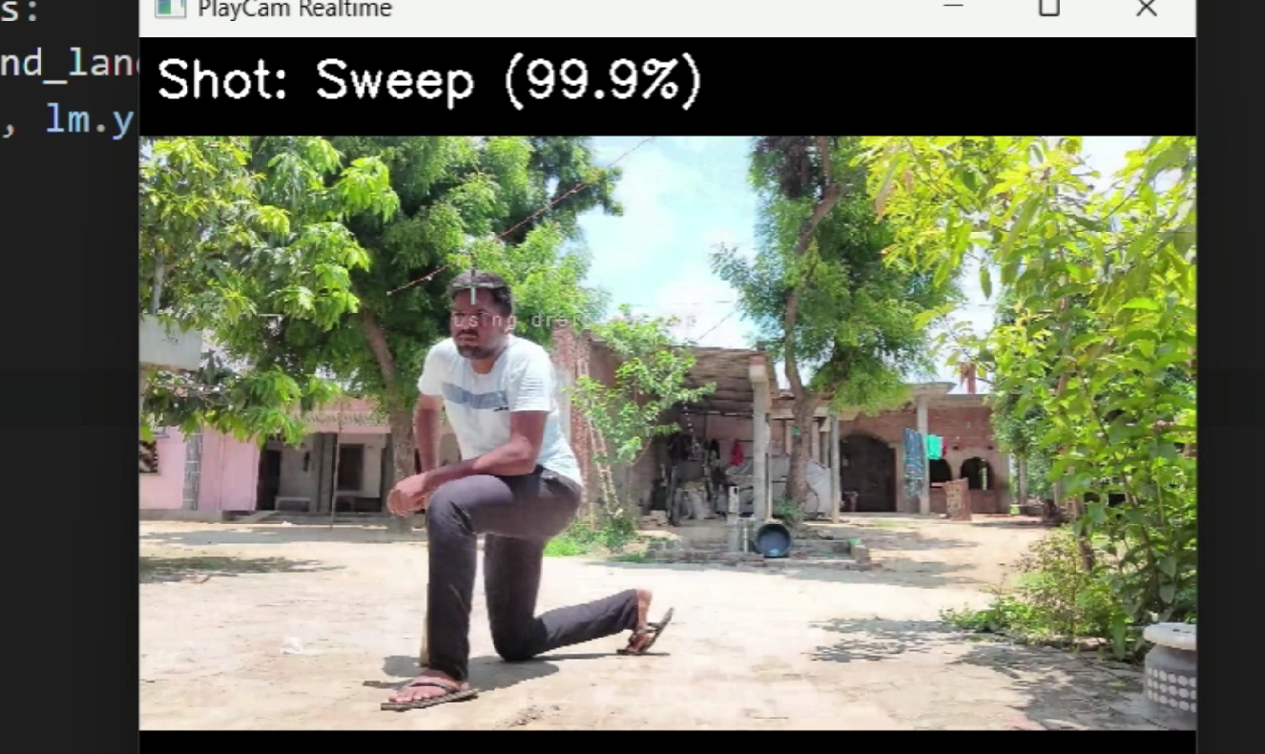

**Previous Approach and Why We Changed It**

At the beginning of the project, I tried a different method. I thought I could train a model by using **images** taken from videos. The plan was to use **CNN (Convolutional Neural Networks)** to detect the shot type based on those images.

But after trying this method, I saw many problems:

* **Accuracy was low** — the model got confused by background, clothes, lighting and angles.
* **Needed a lot of images** to train well, which I didn’t have for now atleast.
* **Real-time performance was very slow** — because images are big and CNNs are heavy.

So, I changed the approach to a better one as I am also a Video Editor and I know the concept of tracking the points, so I got an idea if I just track few points in which mediapipe is expert, after tracking points and saving those data to numerical, I thought this will work better, will train fast and also predicts fast, and guess what ‘It Worked’:

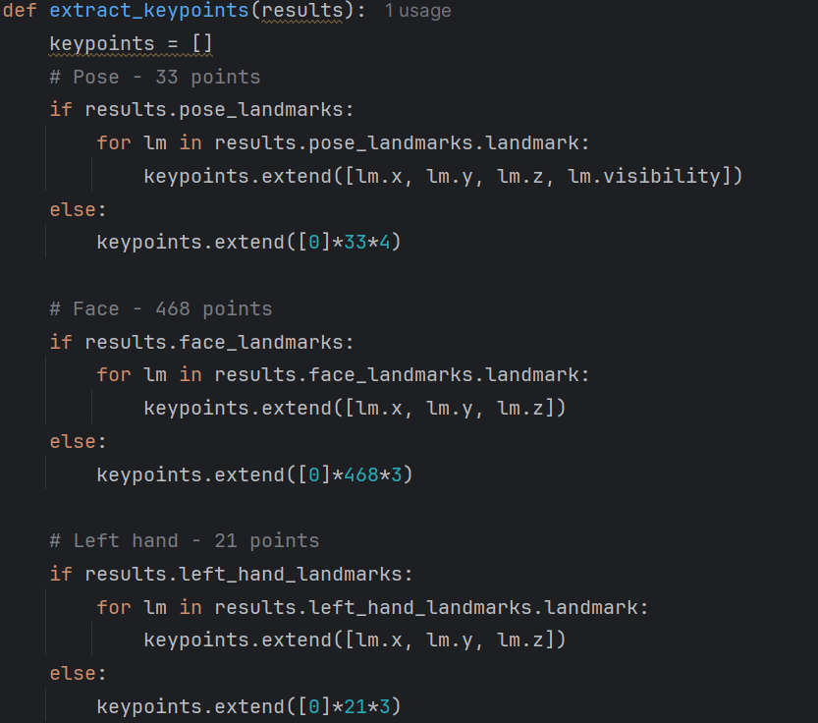

I used **MediaPipe Holistic** to extract pose and body keypoints like face and hand with total 1662 points within a single frame, not raw images.  
These **keypoints are small (just numbers)**, easy for a model to learn from.  
Then I used **LSTM (Long Short-Term Memory)** to learn the full motion using **30-frame sequences**.  
This method was much faster and gave **very high accuracy** — over 98.18%, this much accuracy seems model is overfitting and yes it is, but when we have multiple dataset with variations of frame size, angle, swing speed and even with variation of person.

This switch was the turning point of the project.  
The final system became fast, lightweight, and more accurate — and perfect for real-time use.

**Final Results**

After training and testing the full system, I checked the model both on the saved dataset and in real-time using a webcam. The results were mostly good, but also showed some overfitting where the model performs very well on training data but struggles a bit with real-world inputs but this will defiantly get fixed when multiple datasets with variations are used.

Model Accuracy

The LSTM model was trained on sequences of 30 frames per shot with an overlapping sliding window of 5 frames. It performed extremely well on the dataset:

* Validation Accuracy: 98.18%
* Smooth training curve with low loss and high accuracy
* 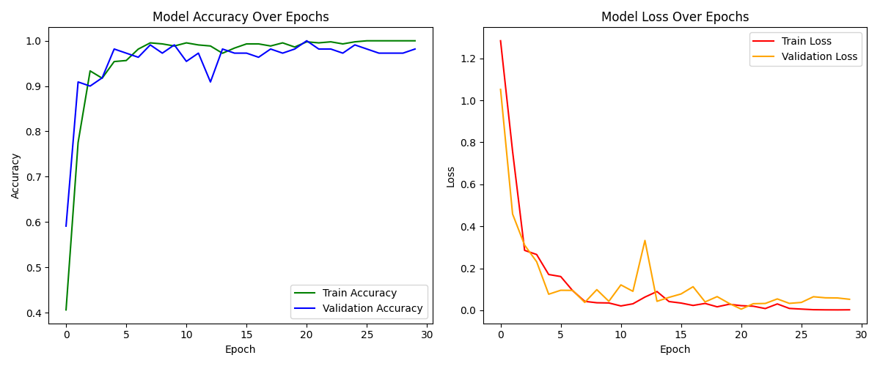 Classification report on test set showed perfect scores

But later I noticed something important…

Overfitting Observed

Even though the model got high accuracy, in real-time webcam testing:

* It sometimes predicted a shot even when no person was visible
* It made mistakes when my pose was not full or body was off-center or any part is out of the frame.
* It memorized my training style too much and that might be because of sliding window to increase the dataset, but this can be fixed.

This shows that the model is slightly overfitting it has learned the training data too well, but cannot fully generalize to new situations yet.

To solve this, we can:

* Add more diverse data (different people, lighting, camera angles, diverse shots, swing speed, direction, frame size etc)
* Use data augmentation

Real-Time Performance

Works well when:

* Body is clearly visible
* Shot is played with proper motion
* Lighting is normal

Misbehaves when:

* No one is in frame(sometimes)
* Camera angle is off
* Movement is incomplete

To fix this, I added a confidence threshold (80%) so the model only predicts when it is sure. If not, it shows:

"No confident shot"

And if >80% Confidence it shows the {Shot_name_label}

Summary Table

|  |  |
| --- | --- |
| Test Type | Result |
| Dataset Accuracy | 98.18% |
| Overfitting Issue | Observed with realtime prediction |
| Confidence Threshold | Set to 80% to reduce wrong guesses |
| Real-time Use | Works well in clean conditions |
| Known Issues | Fails with unclear pose or lighting |

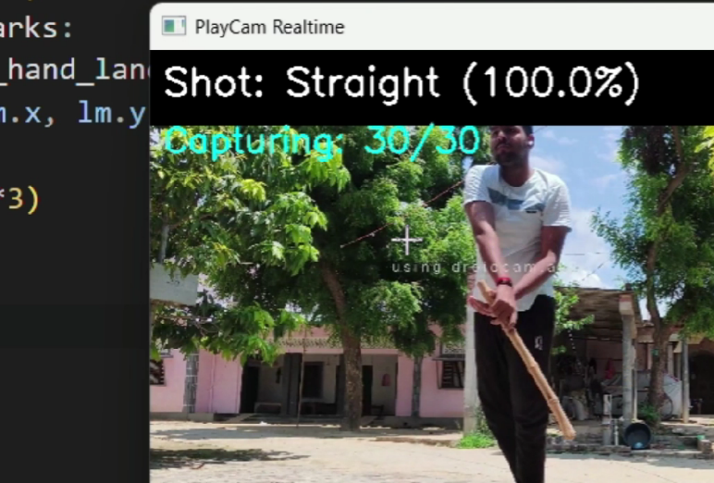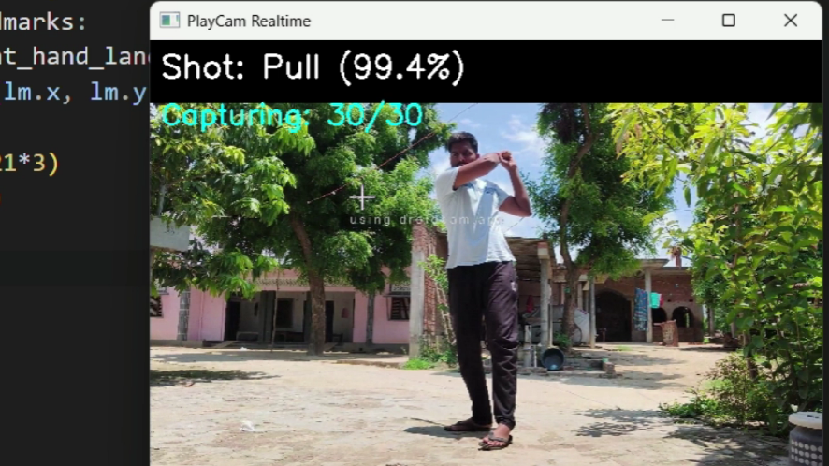

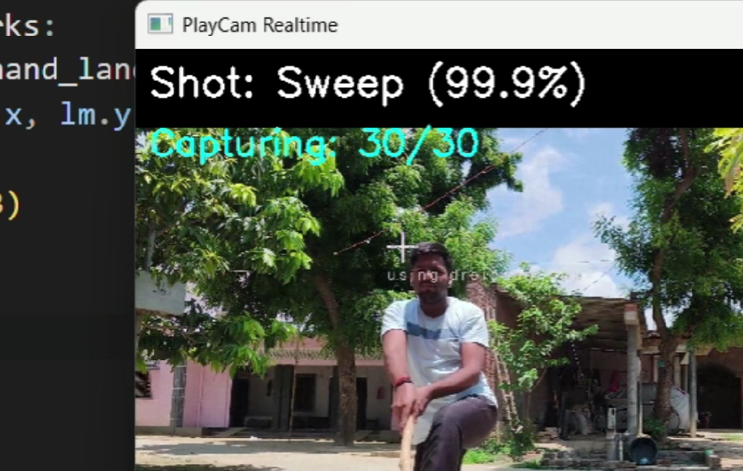

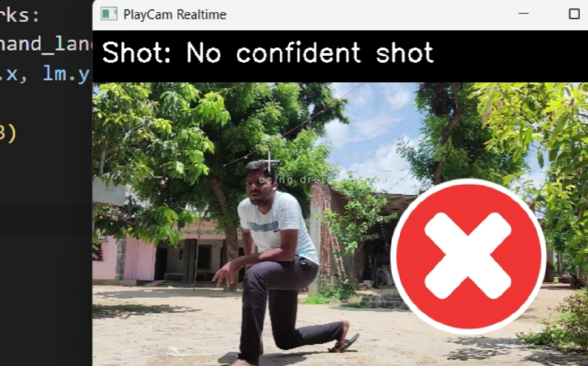

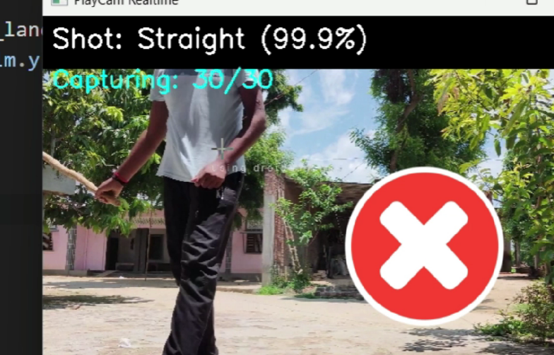

Training Dataset Sample Screenshots

* Cover Drive

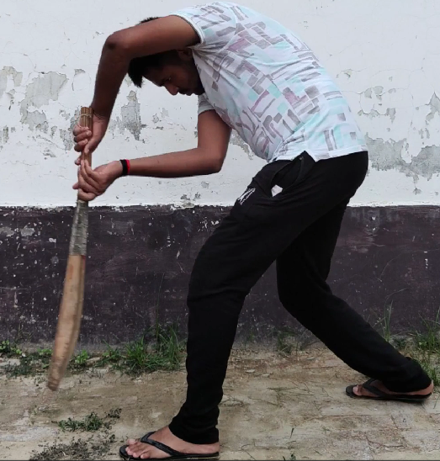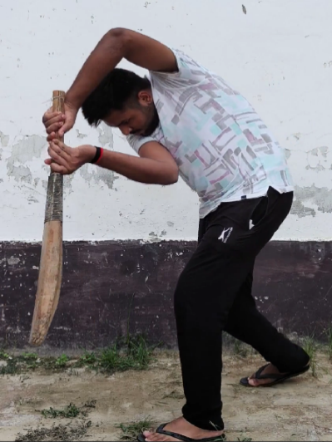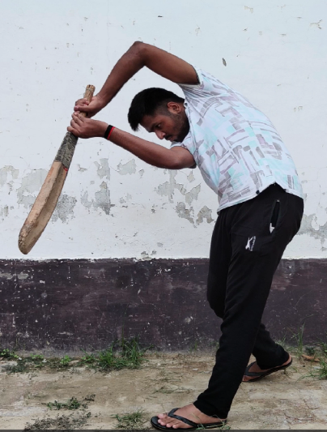

* Straight Drive

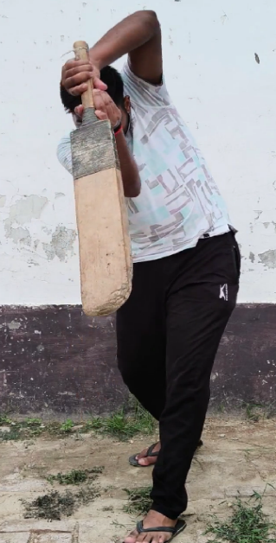

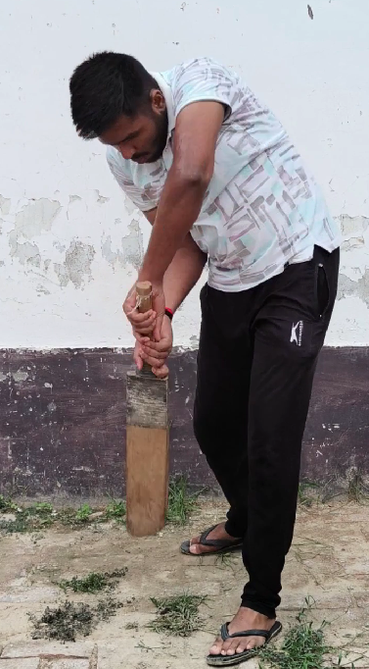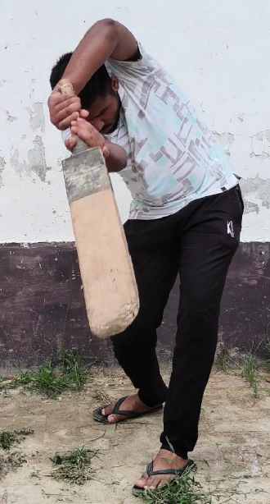

* Pull Shot

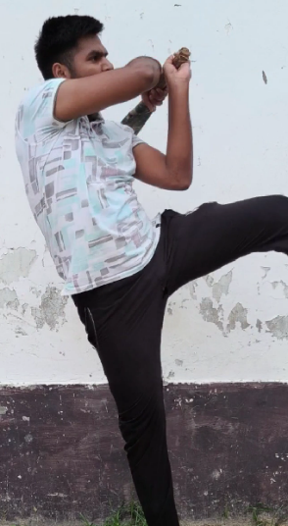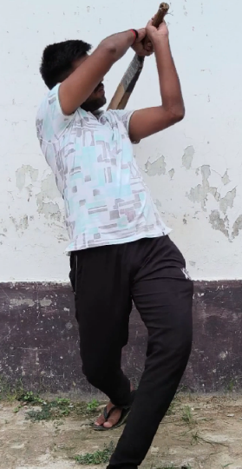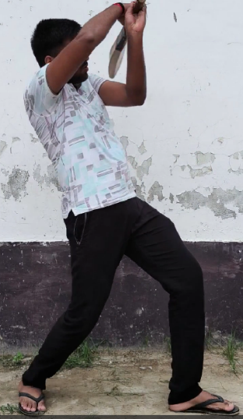

* Sweep Shot

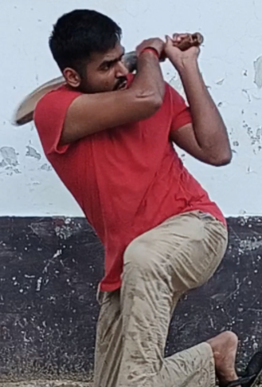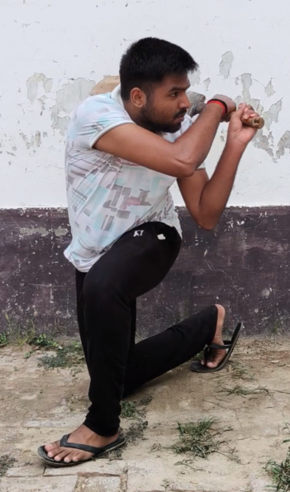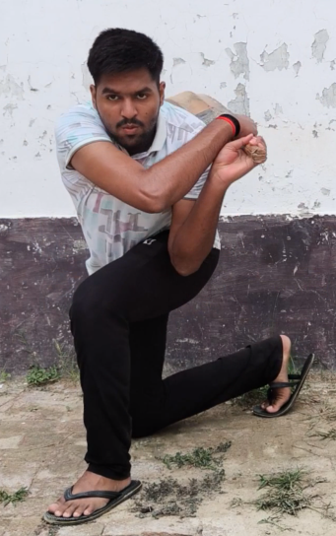

**Conclusion**

This project was a great learning experience for me. I started with the goal of building a system that can understand cricket shots using only a webcam no sensors, no extra cost, and no VR.

In the beginning, I tried image-based training, but it didn’t work well. So I switched to a different approach using **pose keypoints** from **MediaPipe** and trained an **LSTM model** that could understand the full body motion.

After preparing the dataset, extracting the keypoints, training the model, and testing in real time the system finally worked! It was able to recognize **Cover Drive, Pull Shot, Straight Drive, and Sweep** with **high accuracy**, and even showed the predicted shot with confidence on the webcam screen.

Of course, there were some challenges especially in real-time testing like:

* Overfitting on clean data
* Wrong predictions when the body wasn’t fully visible
* Needing a confidence threshold to reduce errors

But I learned how to solve them step by step by tuning the model, adjusting the dataset, and improving the prediction logic.

The final accuracy reached **98.18%**, and the system works smoothly in real-time. I also planned how to connect this system with a cricket game using keyboard or controller inputs which I will implement in future updates, for now controller input is less likely to work for some selected games as they do not support high level inputs.

This was not just a project it was a hands-on journey where I applied everything I had learned and created something that actually works, and this project is something that have took all my skills and hobbies, like interest in games, video editing and yes Machine Learning obviously.

**Future Scope**

This project is currently working well for basic real-time shot prediction using a webcam, but there are many interesting improvements that can be made in the future and actually those are planned before starting of this project.

**1. Connect Fully with Cricket Game**

Right now, I have tested keyboard and controller controls. But in future, I want to fully connect this with cricket games like *Cricket 24* so that shots can be played smoothly inside the game based on body movement even with the variation of shots, their speed, swing speed, nature of shot, direction of shot etc.

**2. Add More Shots**

Currently I have trained the model on 4 shots only Cover, Pull, Straight, and Sweep. Later I want to add more shots like:

* Leg Glance
* Upper Cut
* Lofted Shot
* Defensive Shot
* Flick
* Reverse Sweep
* Supla

This will make it feel more realistic.

**3. Train on More People**

For now, I used only my own videos to train the model. But in future, I want to collect data from **different people**, with different body types, clothes, and camera positions. This will help reduce overfitting and make the model work for everyone.

**4. Make a Simple App or Tool**

In future, I want to make this project into a small desktop app where user can just click one button to start prediction and play the game. Everything will be connected in one window.

**5. Add Voice and Sound**

To make the system more fun, I will try to add **voice feedback** like “Cover Shot Played!” or small cricket sound effects when a shot is detected so that user can know that the shot he played and that one played in the game are delaying how much.

**7. Use in Other Games or Activities**

This idea is not only for cricket. I think it can also be used for:

* Punching games
* Baseball
* Dance games
* Exercise or fitness tracking

Even in every other games where body movement is involved like Jumping, Running, Punching etc

So this is just the start. I really enjoyed building this and I want to keep working on it and make it more powerful and useful in future, and really wanted this for people who can’t afford expensive devices.